SESSION | APR 2025
PROGRAM | BACHELOR OF COMPUTER APPLICATIONS (BCA)
SEMESTER | II
COURSE CODE & NAME | DCA1208 DATABASE MANAGEMENT SYSTEM

Set-I

Q1. A. Classify the types of Database system.
B. Differentiate between Entity Integrity vs. Referential Integrity.
Ans 1.
Classification of Database Systems
Database systems can be classified based on various criteria such as data models, number of users, location, and usage. One common classification is based on data models, which include relational, hierarchical, network, object-oriented, and document-oriented databases.
Relational Database Management Systems (RDBMS) are the most widely used, where data is organized in tables (relations) and can be accessed using SQL. Examples include MySQL, Oracle, and PostgreSQL. Hierarchical databases organize data in a tree-like structure, where each child has only one parent, often used in legacy systems. Network databases allow many-to-many
Its Half solved only
Buy Complete assignment from us
Price – 190/ assignment
MUJ Manipal University Complete SolvedAssignments MARCH 2025
buy cheap assignment help online from us easily
we are here to help you with the best and cheap help
Contact No – 8791514139 (WhatsApp)
OR
Mail us- bestassignment247@gmail.com
Our website - www.assignmentsupport.in

Q2. What do you mean by Keys? What are the different types of Keys? Explain with an example.
Ans 2.
Meaning and Types of Keys in DBMS with Example
Keys in Database Systems
In the context of database systems, keys are crucial elements that help in uniquely identifying records in a table and establishing relationships between tables. A key is one or more attributes (columns) that can be used to retrieve data efficiently and accurately. They ensure data integrity and minimize redundancy in relational databases.
Keys not only help enforce uniqueness in the data but also allow for efficient search, sort, and

Q3. Define an Entity-Relationship Model. List the Components of the ER Diagram.
Ans 3.
Entity-Relationship Model
The Entity-Relationship (ER) Model is a conceptual framework used to describe the structure of a database in terms of entities, their attributes, and the relationships between those entities. Developed by Peter Chen in 1976, the ER model is essential during the database design phase because it provides a high-level view of how data is connected and organized. This model simplifies the process of understanding and modeling real-world data requirements by

Set-II

Q4. Explain the concept of functional dependencies in the context of normalization. How do functional dependencies influence the normalization process? Provide examples.
Ans 4.
Functional Dependencies and Their Role in Normalization
A functional dependency (FD) is a fundamental concept in relational database theory that expresses a relationship between two attributes (or sets of attributes) in a relation. It states that the value of one attribute (or group of attributes) determines the value of another attribute. This concept is crucial in the process of normalization, which aims to eliminate data redundancy and ensure data integrity.
Mathematically, a functional dependency is denoted as X → Y, meaning if two tuples have the

Q5. Consider the Relation Student and write the SQL Queries for the following
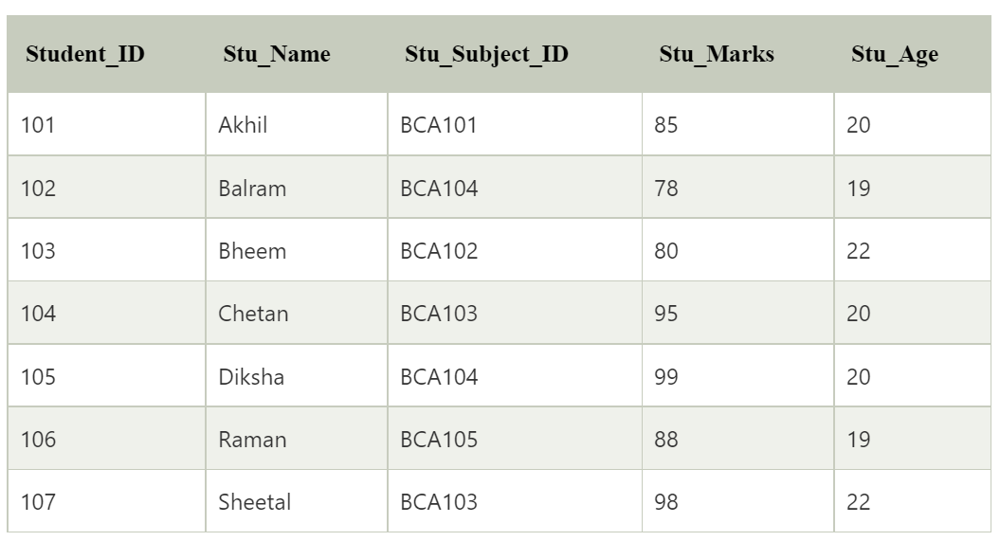
a.Find the name of the students whose name end with ‘n’.
b.Write a query to display the record of the students who belongs to BCA103.
c.Display the record of the students in increasing order of marks
d.Write a query to change the student’s name from Diksha to Deepak.
e.Delete the record of the student whose student id is 107.
Ans 5.
Structured Query Language, commonly known as SQL, is a standard language used to interact with relational databases. It allows users to perform a variety of operations such as inserting, updating, deleting, and retrieving data stored in tables. In the context of the Student table provided, SQL queries help in extracting specific information, updating records, sorting data, and managing entries efficiently.
To find student names ending with a particular character, the SQL LIKE operator is used with a

Q6. A. What do you mean by Transaction? Explain the Transaction states.
B. Discuss the properties of Transaction.
Ans 6.
Meaning of Transaction and Explanation of Transaction States
A transaction in the context of a database management system refers to a logical unit of work that consists of one or more operations. These operations are typically read and write actions on the database. A transaction is performed to carry out a specific task such as updating a record, transferring money between accounts, or processing a purchase. Transactions are crucial because they ensure data consistency and reliability, especially in multi-user environments. A transaction

