|  |  |
| --- | --- |
| **SESSION** | **February - March 2024** |
| **PROGRAM** | **MASTER OF BUSINESS ADMINISTRATION (MBA)** |
| **SEMESTER** | **III** |
| **course CODE & NAME** | **DMBA301 Research methodology** |
| **CREDITS** | **04** |

**Assignment Set – 1st**

**Questions**

**1. What do you understand by Research, explain its meaning and Further discuss various types of research designs?**

**Ans:** Research usually starts with a question or a problem. It is conducted to find solutions through the application of those methods that are systematic and scientific. So we can say that research is a systematic approach to find the solution to a problem.

**Some of the proposed definitions of research are as follows:**

• ‘Research is creative and systematic work used to increase the stock of knowledge in the favour of mankind.’

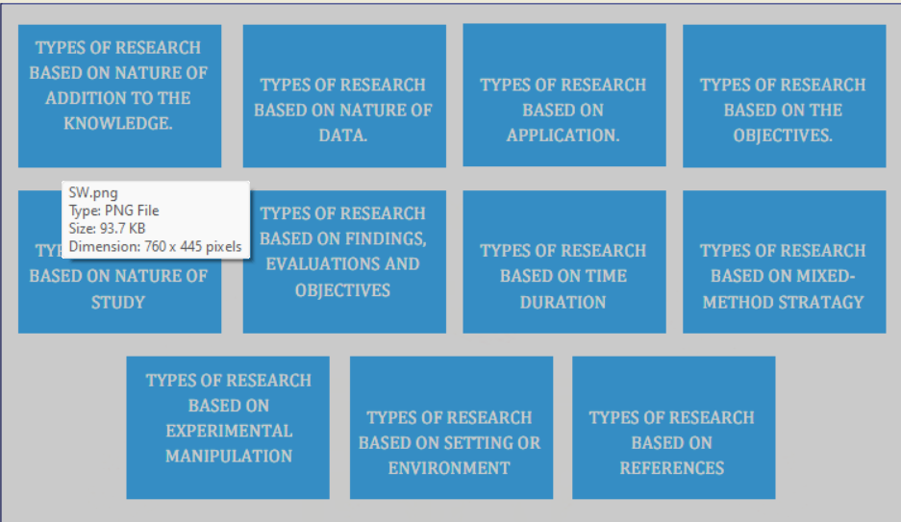

**Types of research**

Its Half solved only

Buy Complete assignment from us

**Price – 190/ assignment**

**MUJ Manipal University Complete SolvedAssignments session FEB 2024**

buy cheap assignment help online from us easily

we are here to help you with the best and cheap help

**Contact No – 8791514139 (WhatsApp)**

**OR**

**Mail us- [bestassignment247@gmail.com](mailto:bestassignment247@gmail.com)**

**Our website -** [**www.assignmentsupport.in**](http://www.assignmentsupport.in)

**2. Discuss various types of data. Further discuss methods of Primary data collection.**

**Ans:Primary data** is data obtained for the first time and thus is unique. This information is in the form of raw material. Also, data collected at the source is referred to as primary data. It is obtained at the point of collection. It is derived directly from first-hand sources through surveys, observations, and experimentation and has not been subjected to any processing or manipulation. It is original and has been obtained for a specific reason directly from the

**3. Describe the relevance of Questionnaire and further discuss and explain various types of questions in it with their importance.**

**Ans:Relevance of Questionnaires**

**Questionnaires** are a vital tool in primary data collection due to their efficiency, versatility, and ability to gather large amounts of data from diverse populations. They are used in various fields such as market research, social sciences, health care, and education.

**The relevance of questionnaires includes:**

**Efficiency:** Questionnaires allow researchers to collect data from a large number of respondents quickly and at relatively low cost.

**Standardization:** By asking the same questions in the same way, questionnaires ensure that

**Assignment Set – 2**

**Questions**

**4. Explain Editing. Discuss various types of editing.**

**Ans:Editing** is the primary step in the data processing. Editing is the process of analyzing data, collected in a survey, to identify errors and omissions and to see that they are corrected and ready for tabulation.

**After all the required data is collected, an editor edits it to ensure the data is as follows:**

• Accurate as possible

• Consistent with other evidence

• Uniformly recorded or entered,

• Is complete as required

**There are different types of editing.**

**These are:**

**A. Editing for Quality:** In this type of editing, the editor checks for any preconceived ideas, misconceptions, or biases. The editor ensures the given information is within limits and that

**5**. **Research proposals and reports are an important component of research. Discuss and further describe various components of research report.**

**Ans:Research proposals** and reports are fundamental to the research process, serving as blueprints and documentation for research projects. A research proposal outlines what the researcher intends to study and how they plan to conduct the study, while a research report provides a detailed account of the research conducted, including the findings and conclusions.

**Components of a Research Proposal**

**Title A**concise statement of the main topic and should capture the essence of the proposed study.

**Abstract A** brief summary of the proposal, usually around 150-250 words, highlighting the

**6. A random sample of 395 people in a country was surveyed to find out if gender is independent of education level. Each person was asked to report the highest education level they had obtained. The data that resulted from the survey is summarized in the following table:**

|  |  |  |  |  |  |
| --- | --- | --- | --- | --- | --- |
|  |  | **HIGH SCHOOL** | **BACHELORS** | **PH. D** | **TOTAL** |
| **FEMALE** | **60** | **54** | **46** | **41** | **201** |
| **MALE** | **40** | **44** | **53** | **57** | **194** |
| **TOTA\L** | **100** | **98** | **99** | **98** | **395** |

**Formulate the hypothesis and test that are gender and education level dependent at 5% level of statistical significance?**

**Ans:** To test whether gender and education level are independent at the 5% level of significance, we can perform a Chi-Square Test of Independence.

**Here is a step-by-step guide to conducting this test:**

**Hypotheses -**

**Null Hypothesis (\(H_0\))**:** Gender and education level are independent. –

**Alternative Hypothesis (\(H_a\))**:** Gender and education level are not independent.

**Data**

**The data collected from the survey is summarized in the following contingency table:**