|  |  |
| --- | --- |
| **SESSION** | **February - March 2024** |
| **PROGRAM** | **MASTER OF BUSINESS ADMINISTRATION (MBA)** |
| **SEMESTER** | **III** |
| **course CODE & NAME** | **DHRM303, Employee Relations management** |
| **CREDITS** | **04** |
| **nUMBER OF ASSIGNMENTS & Marks** | **02**  **30 MARKS EACH** |

**Assignment Set – 1ST**

**Questions**

**1. Explain the following:**

**Corporate level strategy**

**Ans:**Corporate Level Strategy Corporate level strategy is usually devised at the board level.

**It defines the following for an organisation:**

• The overall mission

• The game plans

• The management of the business portfolio

• The priorities of each business unit regarding resource allocation

• The structuring of the business

• The methods of financing the business

• The alliances to be made

• The acquisitions/mergers to be performed. Figure depicts the factors which influence corporate strategy.

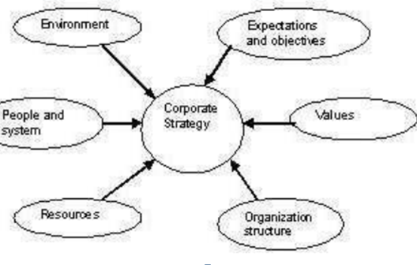

**Factors Influencing Corporate Strategy**

Corporate strategy examines internal (within the company) and external factors (competitors, clients, customers), frames a new vision for the organisation and aligns policies, practices and

Its Half solved only

Buy Complete assignment from us

**Price – 190/ assignment**

**MUJ Manipal University Complete SolvedAssignments session FEB 2024**

buy cheap assignment help online from us easily

we are here to help you with the best and cheap help

**Contact No – 8791514139 (WhatsApp)**

**OR**

**Mail us-** [**bestassignment247@gmail.com**](mailto:bestassignment247@gmail.com)

**Our website -** [**www.assignmentsupport.in**](http://www.assignmentsupport.in)

**2. Explain the following:**

**A. Deal and Kennedy’s classification of Organizational Culture**

**Ans:Deal and Kennedy’s classification:** Deal and Kennedy (1982) classify organisational culture on the basis of feedback and risk factors as follows:

**• The Tough-Guy Macho Culture:** This is a very stressful culture in which feedback is quick and rewards are high. Such culture can be found in brokerage firms or police forces.

**• The Work Hard-Play Hard Culture:** This is present in large organisations, which try to assure good customer service. Here few risks are taken, but feedback is prompt. Team

**3. What do you mean by organizational discipline? Explain the procedure of progressive organization discipline.**

**Ans:Definitions of Organisational Discipline**

W. R. Spriegel and Edward Sohelge define discipline as ‘the force that prompts an individual or groups to observe rules, regulations, and procedures that are deemed necessary to the attainment of an objective’.

Michael J Jucious (1973) defines discipline in the following way: Discipline means that workers willingly abide by company rules and executive orders. To set right the indiscipline

**Assignment Set – 2ND**

**Questions**

**4. What is collective Bargaining? Explain the process of collective Bargaining in detail with suitable example.**

**Ans:Collective Bargaining**:-

It is important to differentiate individual grievances from group grievances. If the issue involves one or a few individual employees, it is handled through a grievance procedure. But when the issue involves policy implications and wider interests, they are resolved by the method known as collective bargaining.

Collective bargaining is a grievance-handling process where a large number of employees are

**5. Explain the various forms of employee participation in detail.**

**Ans:**Employee participation mainly refers to the participation of employees in decision-making. There are many ways to implement it. Employee participation can take both direct and indirect form.

However, direct methods are more popular presently. Research has suggested that an integrated approach to enhance employee participation is better than a non-integrated one.

**6. What is Trade Union? Explain the functions of trade union in detail.**

**Ans:**Trade union: Unions work towards accomplishing goals like increased wages and better working condition for employees. A trade union has a leader who represents the union members. The leader negotiates labour contracts with employers on behalf of the union members. The attitude of trade unions towards MNCs and responses to their impact on collective bargaining vary.

In countries like the Netherlands and the UK, trade unions normally have a positive view of