|  |  |
| --- | --- |
| **SESSION** | **February - March 2024** |
| **PROGRAM** | **MASTER OF BUSINESS ADMINISTRATION (MBA)** |
| **SEMESTER** | **3** |
| **course CODE & NAME** | **DHRM302 – MANAGEMENT & oRGANISATIONAL DEVELOPMENT** |
| **CREDITS** | **04** |

**Assignment Set – 1**

**Questions**

**1. Describe the steps in OD process.**

**Ans:**A logical progression of events is observed by OD Programs. Good execution is an important part of the OD program. You can better understand the various phases of OD program with the help of following figure:-

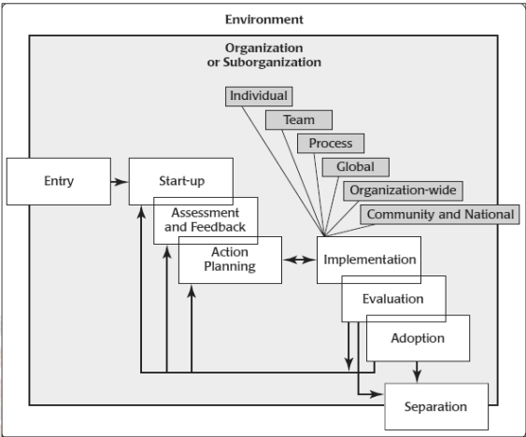

**OD Process Model**

You can see in the figure various stages of the OD process.

**All thesephases can be summarised as:**

1. Making an entry (Entry)

2. Developing the contract (Start up)

3. Launch

Its Half solved only

Buy Complete assignment from us

**Price – 190/ assignment**

**MUJ Manipal University Complete SolvedAssignments session FEB 2024**

buy cheap assignment help online from us easily

we are here to help you with the best and cheap help

**Contact No – 8791514139 (WhatsApp)**

**OR**

**Mail us- [bestassignment247@gmail.com](mailto:bestassignment247@gmail.com)**

**Our website -** [**www.assignmentsupport.in**](http://www.assignmentsupport.in)

**2. Discuss the strategies to manage change with examples.**

**Ans:**Managing change effectively is crucial for organizations to adapt to evolving environments, technologies, and market demands. Various strategies can be employed to ensure smooth transitions and minimize resistance.

**Here are some key strategies to manage change, along with examples:**

**1. Communication Strategy Explanation:** Open, transparent, and frequent communication is essential to inform stakeholders about the change, its reasons, benefits, and impacts.

**3. Explain Lewin’s model of Organisational Change.**

**Ans:**Lewin’s Change Model, is a three step model given by the social scientist Kurt Lewin in the year 1951. He viewed behaviour as dynamic balance of forces working in inverse directions. He believed that such driving forces can help in pushing employees in right direction.

On the other hand, there are some limiting forces which restrict employees to move in the right direction. He claimed that such forces should be analysed and can be easily shifted

understand that certain new relationships are formed, and routines are comforted.

**Assignment Set – 2**

**Questions**

**4. Discuss the factors influencing ethical judgements.**

**Ans:**Qualitative evaluation techniques on the other hand include survey comments, focus group interviews and observations. Such techniques are more time consuming for analysis but provide a rich source ofinformation about contextual data and subtleties. Therefore, a combination of both these evaluation methods remains fruitful in OD intervention evaluation. Organisation surveys are the best evaluation method as it provides both quantitative and

**5. Discuss the different types of qualitative evaluation methods available to managers.**

**Ans:**Now, you can describe the various types of available methods of evaluating interventions both qualitative and quantitative, as:

**1. Experimental – randomised control trial (RCT):** The best accepted gold standard of evaluation is RCT which is used to provide highest quality of evidence to represent the success or failure of ODintervention. In such a method, you first randomly allocate the study population into received or not received intervention. After this randomisation becomes adequate, other factors influencing the outcomes are balanced between intervention and non-

**6. Explain the types of techno-structural interventions with the help of suitable examples.**

**Ans:There are various types of techno-structural interventions as follows:**

• Structural Design

• Downsizing

• Re-engineering

• Parallel Structures

**1 Structural Design** You will find that structural design in contracted sense can be defined as theprocess in which reshaping of the organisation roles and structures are done. You can define it in a broader sense as the alignment of structures, rewards, processes, talent and metrics of an organisation with its business strategy. It tells you how the overall work of an