|  |  |
| --- | --- |
| **SESSION** | **FEBRUARY - MARCH 2024** |
| **PROGRAM** | **MASTER OF BUSINESS ADMINISTRATION (MBA)** |
| **SEMESTER** | **IV** |
| **COURSE CODE & NAME** | **DFIN402 - TREASURY MANAGEMENT** |
|  |  |
|  |  |

**Assignment Set – 1**

**1. Prepare a Note for top Management coveringPrincipal accountabilities of Treasury in your company.**

**Ans 1.**

The Treasury Department plays a crucial role in the financial health and stability of our company. It is responsible for managing the company's liquidity, mitigating financial risks, and ensuring that the company's financial resources are used efficiently. The following note outlines the principal accountabilities of the Treasury in our company.

**Cash and Liquidity Management:** The primary responsibility of the Treasury is to ensure that the company has sufficient liquidity to meet its short-term obligations. This involves

Its Half solved only

Buy Complete assignment from us

**Price – 190/ assignment**

**MUJ Manipal University Complete SolvedAssignments session FEB 2024**

buy cheap assignment help online from us easily

we are here to help you with the best and cheap help

**Contact No – 8791514139 (WhatsApp)**

**OR**

**Mail us-** [**bestassignment247@gmail.com**](mailto:bestassignment247@gmail.com)

**Our website -** [**www.assignmentsupport.in**](http://www.assignmentsupport.in)

**2a. Briefly explain Foreign Exchange Derivatives.**

**b. Mr. X will receive USD 100,000 after one month . There are two scenarios:**

**1. Leave the remittance uncovered.**

**2. Book a forward contract today for one month @ 83.1650.**

**After one month the spot USD/INR rates is expected @ 83.1300/83.2500.**

**Suggest him the better option.**

**Ans 2.**

a. **Foreign Exchange Derivatives**

Foreign exchange derivatives are financial instruments used to hedge or speculate on the movements in currency exchange rates. They derive their value from the underlying currency pair's exchange rate and are essential tools in managing foreign exchange risk. The primary types of foreign exchange derivatives include forwards, futures, options, and swaps.

**Forwards** are customized contracts between two parties to buy or sell a specified amount of

**b. Recommendation for Mr. X on Managing USD Receivable**

Mr. X has two options to manage his upcoming receivable of USD 100,000 after one month: leaving the remittance uncovered or booking a forward contract at a rate of 83.1650. To determine the better option, we must analyze the expected spot rates in one month and the implications of each strategy.

**1. Leaving the Remittance Uncovered:** If Mr. X decides to leave the remittance uncovered,

**3. You have a meeting with your Bank intending to provide your Company their “Integrated Cash Management Services”. List out the points you will discuss with your Bank.**

**Ans 3.**

When meeting with the bank to discuss their Integrated Cash Management Services (ICMS) for our company, it is essential to cover various aspects to ensure that the services align with our financial management objectives and operational needs. The following points should be discussed in detail:

**Comprehensive Overview of Services:** Begin by requesting a detailed explanation of the ICMS offerings. This should include services such as cash concentration, disbursement

**Assignment Set – 2**

**4. Balance Sheet of JKL Company as on 31.03.2024 is given below. Calculate Current Ratio and comment on the funding liquidity position of the company.**

**Industry standard of current ratio for the similar companies ranges from 1.5 to 2.0.**

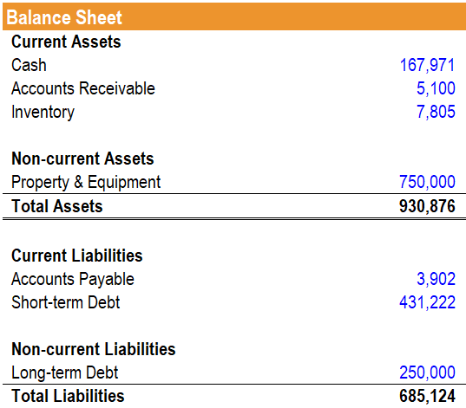

**Ans 4.**

**Current Ratio Calculation**

The current ratio is calculated as follows:

Current Ratio= Current Assets​/ Current Liabilities

From the balance sheet:

Current Assets = 167,971+5,100+7,805=180,876

Current Liabilities = 3,902+431,222=435,124

**5a. Rate Sensitive assets of a Bank as on 31.03.2024 are ₹ 800 cr @ 8% and Rate sensitive liabilities as on 31.03.24 are ₹ 1000 cr @ 5%. Calculate Gap as on 31.03.2024 and Net Interest Income of the Bank.**

**b. If interest rates on assets and liabilities reduce by 100 basis points (1%),calculate the impact on the NII (Net Interest Income) of the Bank.**

**c. Comment on the impact on NII if the GAP is positive and interest rates reduces.**

**Ans 5.**

**a. Calculation of Gap and Net Interest Income (NII)**

**Rate-Sensitive Assets (RSA):**

* Total: ₹800 crore
* Interest Rate: 8%

**Rate-Sensitive Liabilities (RSL):**

* Total: ₹1000 crore
* Interest Rate: 5%

**Gap Calculation:**

Gap=RSA−RSL=800crore−1000crore=−200crore

**6. During the course of managing working capital of your company, you found that current ratio is high but current assets are rising disproportionately to the turnover.**

**Analyze the implications of this situation.**

**Ans 6.**

**Implications of a High Current Ratio with Disproportionate Rise in Current Assets Relative to Turnover**

Managing working capital efficiently is crucial for maintaining the financial health and operational effectiveness of a company. A high current ratio typically indicates that a company has sufficient current assets to cover its short-term liabilities, which is generally perceived as a sign of good liquidity. However, when current assets rise disproportionately to