|  |  |
| --- | --- |
| **SESSION** | **February/MARCH 2024** |
| **PROGRAM** | **Master of CoMPUTER APPLICATIONS (MCA)** |
| **SEMESTER** | **I** |
| **course CODE & NAME** | **DCA6103 – Foundation of Mathematics** |
| **CREDITS** | **4** |
| **nUMBER OF ASSIGNMENTS & Marks** | **02 Sets & 30 Marks** |

**Set-Ist**

**1. Check whether the following is Tautology or Contradiction:**

**a. (p∨q)∨(∼p)**

**Ans:** To determine whether the given logical expressions are tautologies or contradictions, we need to evaluate their truth values for all possible combinations of truth values of their constituent propositions (p and q).

**Let's evaluate each expression:**

**a. (p∨q)∨(∼p)**

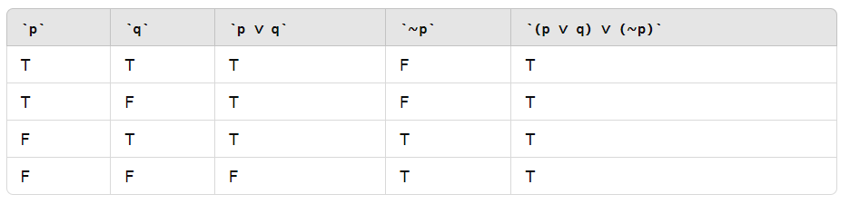

Since the expression (p∨q)∨(∼p) evaluates to true for all possible truth values of p and q, it is a tautology.

**b. ∼[p∨(∼p)]**

**Ans:**

Its Half solved only

Buy Complete assignment from us

**Price – 190/ assignment**

**MUJ Manipal University Complete SolvedAssignments session FEB 2024**

buy cheap assignment help online from us easily

we are here to help you with the best and cheap help

**Contact No – 8791514139 (WhatsApp)**

**OR**

**Mail us- [bestassignment247@gmail.com](mailto:bestassignment247@gmail.com)**

**Our website -** [**www.assignmentsupport.in**](http://www.assignmentsupport.in)

**3. Find 2nd order partial derivative, (∂^2 f)/(∂x^2 ), (∂^2 f)/(∂y^2 ) and (∂^2 f)/∂x∂yof f(x,y)=xe^y+ye^x.**

**Ans:** To find the second-order partial derivatives of the function 𝑓 ( 𝑥 , 𝑦 ) = 𝑥𝑒𝑦 + 𝑦𝑒𝑥 f(x,y)=xe y +ye x , we'll start by finding the first-order partial derivatives with respect to 𝑥 x and 𝑦 y, and then we'll differentiate those results again with respect to 𝑥 x and 𝑦 y, respectively.

**First-order partial derivatives: ∂ 𝑓 ∂ 𝑥 ∂x ∂f ​** :

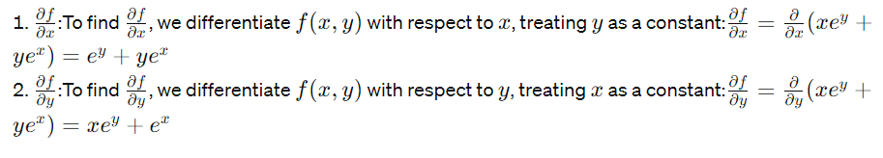

**Set-IInd**

**4. Find the scalar and vector product of (A ) ⃗=(i ) ̂+(j ) ̂+3(k ) ̂ and (B ) ⃗=-2(i ) ̂+(j ) ̂+2(k ) ̂ .**

**Ans:**To find the scalar and vector products of two vectors \( \mathbf{A} \) and \( \mathbf{B} \), we'll first express the given vectors in terms of their components, and then apply the relevant formulas.

Given:

\[ \mathbf{A} = \mathbf{i} + \mathbf{j} + 3\mathbf{k} \]

\[ \mathbf{B} = -2\mathbf{i} + \mathbf{j} + 2\mathbf{k} \]

**Scalar Product (Dot Product):**

**5. Apply Cramer’s rule to solve the system of equations: 3x+y+2z=3; 2x-3y-z=-3; x+2y+z=4.**

**Ans:**To solve the given system of equations using Cramer's rule, we'll first express the system in matrix form and then apply the rule to find the values of \( x \), \( y \), and \( z \).

**The system of equations can be expressed as:**

\[ \begin{cases} 3x + y + 2z = 3 \\ 2x - 3y - z = -3 \\ x + 2y + z = 4 \end{cases} \]

**6. Express the following complex numbers in the polar form and hence find their modulus and amplitude.**

**(i) √3+i**

**Ans:**To express a complex number in polar form, we need to represent it in terms of its modulus (magnitude) and argument (angle). Then, we can use trigonometric functions to find these values.

**Let's find the polar form, modulus, and argument for each complex number:**

**(i) \( \sqrt{3} + i \)**

**First, let's find the modulus (\( r \)) and argument (\( \theta \)):**

\[ r = |z| = \sqrt{(\sqrt{3})^2 + 1^2} = \sqrt{3 + 1} = 2 \]

To find the argument (\( \theta \)), we'll use the formula:

\[ \theta = \text{atan2}(b, a) \]