|  |  |
| --- | --- |
| **SESSION** | **MARCH 2024** |
| **PROGRAM** | **BCA** |
| **SEMESTER** | **II** |
| **course CODE & NAME** | **DCA1203-Object Oriented Programming – C++** |
| **CREDITS** | **4** |

**Set-Ist**

**1. Describe the various datatypes available in C++?**

**Ans:**

**Data types**

A data type in a programming language is a set of data with values having predefined characteristics. Like C language, C++ also supports different data types. C++ language supports the following data types: char, int, float, double. The basic datatypes have various modifiers preceding them.

The list of modifiers is: signed, unsigned, long and short.

Its Half solved only

Buy Complete assignment from us

**Price – 190/ assignment**

**MUJ Manipal University Complete SolvedAssignments session FEB 2024**

buy cheap assignment help online from us easily

we are here to help you with the best and cheap help

**Contact No – 8791514139 (WhatsApp)**

**OR**

**Mail us- [bestassignment247@gmail.com](mailto:bestassignment247@gmail.com)**

**Our website -** [**www.assignmentsupport.in**](http://www.assignmentsupport.in)

**2. What is the difference between the do-while and the while statements?**

**Ans:**The primary difference between do-while and while statements in programming lies in when the condition is evaluated and how many times the loop's body is guaranteed to execute.

**Here are the key differences and some example code snippets to illustrate:**

**While Statement Condition Evaluation:** The condition is evaluated before the loop body is executed.

**Execution Guarantee:** The loop body may not execute at all if the condition is false from the

**3. Brief about class and objects.**

**Ans:Classes and Objects in Object-Oriented Programming (OOP) Class**

A class is a blueprint or template for creating objects. It defines a set of attributes and methods that the created objects will have. A class encapsulates data for the object and methods to manipulate that data. Essentially, it represents a real-world entity or concept.

**Key Characteristics of a Class:**

**Attributes (Fields):** Variables that hold the data or properties of an object.

**Methods (Functions):** Functions defined within a class that describe the behaviors or actions

**Set-IInd**

**4. Define exception. Explain exception handling mechanism.**

**Ans:**

**Exception Handling Mechanism**

The exception handling mechanism in C++ is built upon the three keywords named as try, throw and catch. The block of statements which generates exceptions are prefaced by the “try” keyword. These blocks of statements are called “try block”. When, an exception is detected, it is thrown using a throw statement in the try block. A “catch block” defined by the keyword “catch” catches the exception thrown by the throw statement in the try block, and

**5. List and explain the STL components.**

**Ans:**

STL Components

There are many components present in STL. But there are three major components in STL namely:

• Containers

• Algorithms

•Iterators.

These components work together to provide support to a variety of programming solutions. Figure 1 shows the relationship between the three components of STL. Algorithms employ iterators to perform operations stored in containers.

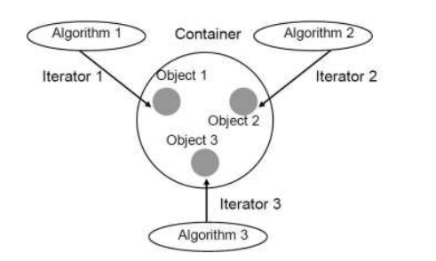

**Relationship between the three STL components**

1 Containers The containers are objects that hold data of the same type. It is a way data is

**6. Explain the types of methods to open a file.**

**Ans:**

Opening a file For opening a file you have to create a file stream and link it to a filename. You can define a filename using if stream, of stream and fstream classes. These classes are contained in the header file fstream. Selection of classes which you are going to use depends on the purpose, i.e., whether you want to write data to the files or to read data from the files.