|  |  |
| --- | --- |
| **SESSION** | **MARCH 2024** |
| **PROGRAM** | **BACHELOR of CoMPUTER APPLICATIONS (BCA)** |
| **SEMESTER** | **II** |
| **course CODE & NAME** | **DCA1202 - Data Structure and Algorithm** |
| **CREDITS** | **4** |

**Set-IST**

**1. What are the characteristics and Building Blocks of an Algorithm? And what are Control Mechanism and Control structures?**

**Ans:**

**Characteristics of an Algorithm**

An algorithm is a step-by-step procedure or formula for solving a problem.

**The key characteristics of an algorithm include:**

**Finiteness:** An algorithm must always terminate after a finite number of steps. This ensures that the algorithm will eventually provide a solution to the problem.

**Definiteness:** Each step of the algorithm must be precisely defined. The actions to be carried out should be clear and unambiguous.

Its Half solved only

Buy Complete assignment from us

**Price – 190/ assignment**

**MUJ Manipal University Complete SolvedAssignments session FEB 2024**

buy cheap assignment help online from us easily

we are here to help you with the best and cheap help

**Contact No – 8791514139 (WhatsApp)**

**OR**

**Mail us- [bestassignment247@gmail.com](mailto:bestassignment247@gmail.com)**

**Our website -** [**www.assignmentsupport.in**](http://www.assignmentsupport.in)

**2. A. What are Binary trees? How many types of Binary trees are there, discuss?**

**Ans:**

**Definition**: A binary tree is a special case of tree where no node of a tree can have a degree of more than two. Therefore, a binary tree is a set of zero or more nodes T such that:

i) There is a specially designated node called the root of the tree

ii) The remaining nodes are partitioned into two disjointed sets, T1 and T2, each of which is a

**B. Discuss the linked storage representation of binary tree.**

**Ans:Linked storage representation of binary tree** The most popular way to present a binary tree is Linked storage representation. Binary tree consists of nodes which can have at most two child, linked representation of such tree will be stored in the form shown Fig, where LPTR and RPTR denote the address or locations of the left and right sub trees respectively of

**3. Explain the algorithms of Bubble sort and Merge sort.**

**Ans:**

**Bubble sort Bubble sort** is a straightforward and simplistic method of sorting data that is used very commonly. The algorithm starts at the beginning of the data set. It compares the first two elements, and if the first is greater than the second, then it swaps them. It continues doing this for each pair of adjacent elements to the end of the data set. It then starts again with the first two elements, repeating until no swaps have occurred on the last pass. This

**Set-IIND**

**4. A. What is dynamic memory storage and how is link list stored in memory? Write the algorithm for traversal of a singly link list.**

**Ans:Dynamic representation**

The efficient way of representing a linked list is using the free pool of storage. In this method, there is a memory bank (which is nothing but a collection of free memory spaces) and a memory manager (a program, in fact). During the creation of a linked list, whenever a node is required the request is placed to the memory manager; the memory manager will then

**B. What are the different types of link list? Write an algorithm to create circular list.**

**Ans:**

## Types of Linked Lists:-

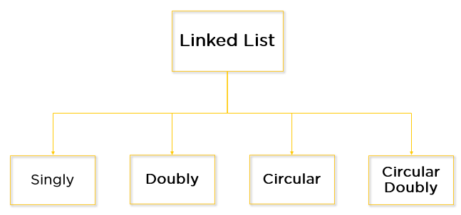

**There are four key types of linked lists:**

* Singly linked lists
* Doubly linked lists
* Circular linked lists
* Circular doubly linked lists

**Algorithm**

1. Step 1: IF PTR = NULL.

**6. A. What is Stack? Discuss the Array implementation of a stack along with push () and pop() algorithms.**

**Ans:**

**Stack**

A stack is a data structures in which insertion and deletion of items are made at the one end, called the top of the stack.

We have two basic operations in stack they are push and pop.

**Push Operation:** Push is used to insert an item into a stack.

**Pop Operation:** Pop is used to delete an item from a stack.

**B. What is Queue? Discuss the Array implementation of a queue along with enqueue () and Dequeue() algorithms.**

**Ans:**

**Queue**

A queue is a linear list of elements in which deletions can take place only at one end, called the front and insertions can take place only at the other end, called the rear as referred in the figure. The terms “front” and “rear” are used in describing a linear list only when it is implemented as a queue.

Following are the two methods offered by queue for adding and deleting element from the queue.