|  |  |
| --- | --- |
| **SESSION** | **February/MARCH 2024** |
| **PROGRAM** | **Bachelor of CoMPUTER APPLICATIONS (BCA)** |
| **SEMESTER** | **I** |
| **course CODE & NAME** | **DCA1103 – Basic Mathematics** |
| **CREDITS** | **4** |

**Set-I**

1. **By using truth tables, check whether the propositions $\sim (p∧q)$ and $(∼p)∨\left(∼q\right)$ are logically equivalent or not?**

**Ans:**

To determine if the propositions ¬ ( 𝑝∧𝑞 ) ¬(p∧q) and ¬ 𝑝∨ ¬ 𝑞 ¬p∨¬q are logically equivalent, we can construct truth tables for both propositions and compare their truth values for all possible truth values of 𝑝 p and 𝑞 q.

Step-by-Step Construction of Truth Tables

**List all possible truth values for p and q:-**

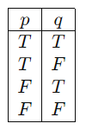

1. **A Spaceship moves in a circular orbit of radius 7200 KM around the earth. How far does it travel while sweeping an angle of ${100}^{0}$.**

**Ans:**

To determine how far a spaceship travels while sweeping an angle of 10 0 ∘ 100 ∘ in a circular orbit with a radius of 7200 km around the Earth, we can use the formula for the arc length of a circle.

**The arc length s is given by:**

**𝑠 = 𝑟𝜃**

**s=rθ**

**Where:** 𝑟 r is the radius of the circle; 𝜃 θ is the central angle in radians. First, we need to

Its Half solved only

Buy Complete assignment from us

**Price – 190/ assignment**

**MUJ Manipal University Complete SolvedAssignments session FEB 2024**

buy cheap assignment help online from us easily

we are here to help you with the best and cheap help

**Contact No – 8791514139 (WhatsApp)**

**OR**

**Mail us- [bestassignment247@gmail.com](mailto:bestassignment247@gmail.com)**

**Our website -** [**www.assignmentsupport.in**](http://www.assignmentsupport.in)

**2.**

1. **Find the nth term of the sequence $3, 2, \frac{5}{3}, \frac{6}{4}, \frac{7}{5},…$ and find its limit if exist.**

**Ans:**To find the 𝑛 n-th term of the sequence 3 , 2 , 5 3 , 6 4 , 7 5 , … 3,2, 3 5 ​ , 4 6 ​ , 5 7 ​ ,…, we need to look for a pattern in the sequence.

**Let's denote the n-th term of the sequence by 𝑛 a n ​ .**

**Observing the first few terms, we see:** 𝑎 1 = 3 = 4 1 , 𝑎 2 = 2 = 4 2 , 𝑎 3 = 5 3 , 𝑎 4 = 6 4 , 𝑎 5 = 7 5 . a 1 ​ a 2 ​ a 3 ​ a 4 ​ a 5 ​ ​ =3= 1 4 ​ , =2= 2 4 ​ , = 3 5 ​ , = 4 6 ​ , = 5 7 ​ . ​

It appears that the n-th term of the sequence has the form: 𝑎𝑛 = 𝑛 + 3 𝑛 a n ​ = n n+3 ​

**b. Find the value of ${\left(-1+i\sqrt{3}\right)}^{10}$ using De Moivre’s theorem.**

Tofind the value of ( − 1 + 𝑖 3 ) 10 (−1+i 3 ​ ) 10 using De Moivre's theorem, we first need to express the complex number in polar form.

**Step 1: Convert to Polar**

Form A complex number = 𝑎 + 𝑏𝑖 z=a+bi can be expressed in polar form as = 𝑟 ( cos ⁡ 𝜃 + 𝑖 sin ⁡ 𝜃 ) z=r(cosθ+isinθ), where: 𝑟 = ∣𝑧∣ r=∣z∣ is the modulus of the complex number,

**3. Apply Cramer’s rule to solve the system of equations: $3x+y+2z=3$; 2 $x-3y-z=-3$; $x+2y+z=4$.**

**Sol:- To solve the system of equations using Cramer's rule, we need to follow these steps: Write down the system of equations in matrix form:**

**{ 3𝑥 + 𝑦 + 2 𝑧 = 3 2 𝑥 − 3 𝑦 − 𝑧 = − 3 𝑥 + 2 𝑦 + 𝑧 = 4   
 3x+y+2z=3 2x−3y−z=−3 x+2y+z=4}**

**​**

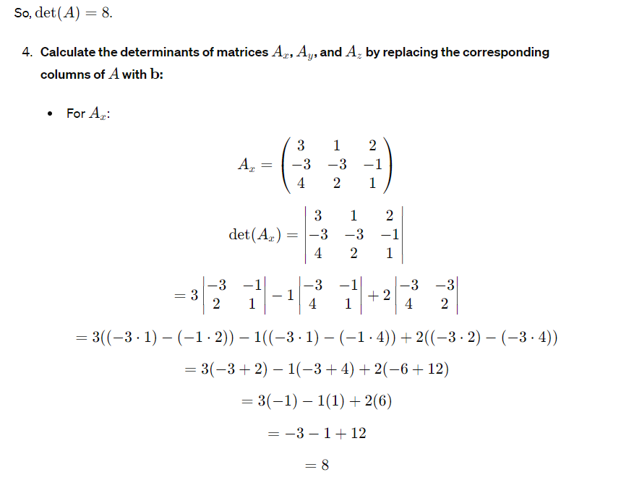

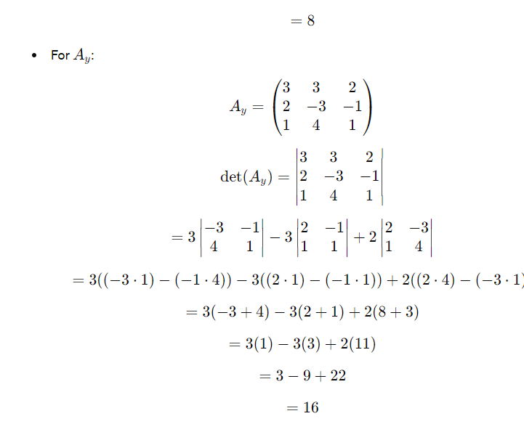

**Set-II**

**4. One card is drawn from a well shuffled deck of 52 cards. If each outcome is equally likely, calculate the probability that the card will be**

**(i) a diamond (ii) not a black card**

**(iii) a black card (i.e., a club or, a spade) (iv) not a diamond.**

**Ans:**

To calculate the probabilities of drawing specific types of cards from a well-shuffled deck of 52 cards, we'll use basic probability principles. Each outcome (drawing a specific card) is equally likely, so the probability of drawing a specific type of card can be found by dividing

**5. In an office there are 84 employees. Their salaries are as given below:**

|  |  |  |  |  |  |  |
| --- | --- | --- | --- | --- | --- | --- |
| **Salary (Rs.)** | **2430** | **2590** | **2870** | **3390** | **4720** | **5160** |
| **Employees** | **4** | **28** | **31** | **16** | **3** | **2** |

**i) Find the mean salary of the employees**

**ii) What is the total salary of the employees?**

**Ans:**

**To find the mean salary of the employees and the total salary of the employees, we can follow these steps:**

**i) Find the Mean Salary**

**The mean salary can be found using the formula for the weighted mean, which is given by:**

\[

\text{Mean} = \frac{\sum (x_i \cdotf_i)}{\sum f_i}

\]

where:

- \(x_i \) is the salary.

- \(f_i \) is the number of employees receiving that salary.

- \(\sum (x_i \cdotf_i)\) is the total salary paid to all employees.

- \(\sum f_i\) is the total number of employees.

**Let's calculate each term:**

\[

\

**6. Consider 77, 73, 75, 70, 72, 76, 75, 72, 74, 76. Give standard deviation for the numbers given above.**

**Ans:**

To find the standard deviation of the given numbers, we need to follow these steps: Calculate the mean (average) of the numbers. Calculate the variance, which is the average of the squared differences from the mean. Take the square root of the variance to get the standard deviation.

**Step 1:** Calculate the Mean First, sum up all the numbers and then divide by the count of numbers.

**Mean =** ∑ 𝑖 = 1 𝑛𝑥𝑖𝑛

