|  |  |
| --- | --- |
| **SESSION** | **April 2024** |
| **PROGRAM** | **BACHELOR of business administration (BBA)** |
| **SEMESTER** | **III** |
| **course CODE & NAME** | **DBB2104 – Financial management** |
| **CREDITS** | **4** |

**Assignment Set – 1ST**

**Questions**

**1. Explain the functions of a financial manager in any organization.**

**Ans:**A finance manager is a person who is responsible for carrying out the functions of a finance department. Let us discuss the main functions of finance managers.

Financial managers play a crucial role in organizations by managing the financial health and resources to achieve the organization's objectives. Their functions encompass a broad range of responsibilities, spanning financial planning, analysis, decision-making, and reporting.

**Here are the key functions of a financial manager in any organization:**

**Financial Planning:**

Develop and implement financial plans aligned with the organization's goals and objectives.

Its Half solved only

Buy Complete assignment from us

**Price – 190/ assignment**

**MUJ Manipal University Complete SolvedAssignments session APRIL 2024**

buy cheap assignment help online from us easily

we are here to help you with the best and cheap help

**Contact No – 8791514139 (WhatsApp)**

**OR**

**Mail us- [bestassignment247@gmail.com](mailto:bestassignment247@gmail.com)**

**Our website -** [**www.assignmentsupport.in**](http://www.assignmentsupport.in)

**2. Calculate the present value of the following cash flows assuming a discount rate of 10% per annum.**

|  |  |
| --- | --- |
| **Year** | **Cash flows [₹]** |
| **1** | **10000** |
| **2** | **20000** |
| **3** | **30000** |
| **4** | **40000** |
| **5** | **50000** |

**Ans:Here we will use the following formula:**

**PV = FV / (1 + r %)n**

**Where,**

FV

= Future value, PV

= Present value, r

= rate of interest

= 10%,

**3. X ltd issued Rs 100, equity shares at a premium of 10%. At the end of the year, the expected dividend is 15% which is expected to grow 8% p.a.**

**A. Calculate the cost of equity.**

**Ans:**To calculate the cost of equity for X Ltd, we need to consider two scenarios based on the information provided:

**Scenario A:** Growing Dividends In this scenario, we use the Gordon Growth Model (Dividend Discount Model), which accounts for a constant growth rate in dividends.

**B. If dividends are constant, and then what will be the cost of equity?**

**Ans:Constant Dividends In this scenario, we assume dividends remain constant and do not grow.**

**The formula for the cost of equity ( k e ​ ) is simplified to:**

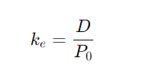

**Where:** 𝐷

D is the constant dividend. 𝑃 0

**Assignment Set – 2**

**Questions**

**4. What are the sources of finance? Discuss the short term and long term sources of finance for the firm.**

**Ans:**A source or sources of finance, refer to where a business gets money from to fund their business activities. A business can gain finance from either internal or external sources.

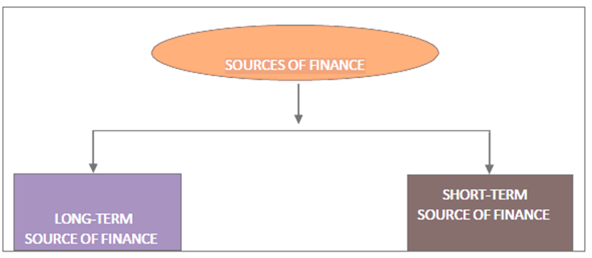

**SOURCE OF FINANCE**

Long term finance or long-term capital forms the financial foundation of a firm. It is important because it is the only source of financing for the firm up to the income generating stage. It is required to finance fixed assets and also for core working capital. Long-term

**5. The details regarding three companies are given below:**

|  |  |  |
| --- | --- | --- |
| **X Ltd** | **Y Ltd** | **Z Ltd.** |
| **r = 12%** | **r = 8%** | **r = 10%** |
| **Ke = 10 %** | **Ke = 10 %** | **Ke = 10 %** |
| **E = Rs. 100** | **E = Rs. 100** | **E = Rs. 100** |

**Compute the value of an equity share of each of these companies applying Walter’s formula when the dividend pay-out ratio is (a) 0%, (b) 20%, (c) 40%.**

**Ans:According to Waltor's Model**

$$P=\frac{D+\frac{r}{Ke}(E-D)}{Ke}$$

**Where. $D=$**  
 Dividend per share

$r=$ Rate of return

**6. What is Working capital management? Discuss various factors that affect working capital requirement?**

**Ans:**WC typically means the firm’s holding of current or short-term assets such as cash, receivables, inventory and marketable securities. These items are also referred to as circulating capital. Corporate executives devote considerable amount of attention to the management of WC.

**Working capital management** is related to short-term assets or current assets. This integral part of financial management is very important as short-term survival is the basis for long-