|  |  |
| --- | --- |
| **SESSION** | **MARCH 2023** |
| **PROGRAM** | **MASTER of business administration (mBA)** |
| **SEMESTER** | **II** |
| **course CODE & NAME** | **dmba201 – PRODUCTION AND OPERATIONS MANAGEMENT** |
| **CREDITS** | **4** |
| **nUMBER OF ASSIGNMENTS & Marks** | **02**  **30 Marks each** |

**Assignment Set – 1**

**1(a). Explain the functions of Production Planning and Control**

**Ans 1(a)**

**Functions of Production Planning and Control**

The functions of production control are dispatching and expediting. Figure depicts the production control function.

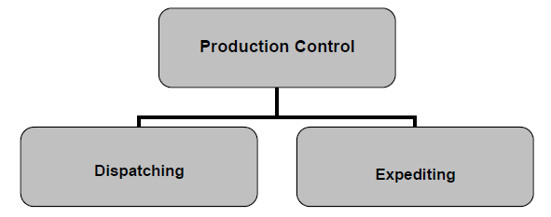

**Production Control Function**

**Dispatching –** Dispatching is concerned with setting production activities in motion. The production activities include issuing material release orders and moving materials from work centre to work centre, meeting the requirements of routing and

Its Half solved only

Buy Complete assignment from us

**Price – 190/ assignment**

**MUJ Manipal University Complete SolvedAssignments session March 2023**

buy cheap assignment help online from us easily

we are here to help you with the best and cheap help

**Contact No – 8791514139 (WhatsApp)**

**OR**

**Mail us-** [**bestassignment247@gmail.com**](mailto:bestassignment247@gmail.com)

**Our website -** [**www.assignmentsupport.in**](http://www.assignmentsupport.in)

**2(a). Discuss Strategic Importance of Forecasting**

**Ans 2(a)**

**Strategic Importance of Forecasting**

Forecast is very much required for all types of industrial activity and also for those industries which are purely in the service sector like healthcare and education. Good forecasts are of critical importance in all aspects of a business: The forecast is the only estimate of demand until the actual demand becomes known. Therefore, forecast is said to drive decisions in

**2(b). Why redesign of existing layout may be necessary?**

**Ans 2(b)**

Many occasions demand a redesign of existing layout both due to expansion of capacity and due to technical reasons. Most common reasons for redesign of layouts include the following:

**Efficiency and productivity improvement:** A redesign may be required to optimize the layout and improve workflow efficiency. By analyzing the current layout, identifying

**3(a). Describe the general factors that influence the plant location decision.**

**Ans 3a.**

The decision of where to locate a plant is influenced by various factors that can be broadly categorized into economic, geographic, political, and social factors. Here are some of the general factors that influence the plant location decision:

1. **Proximity to Raw Materials:** The availability and proximity of raw materials are crucial considerations. Industries that rely heavily on raw materials, such as mining or

**3(b) State the elements of operations strategy.**

**Ans 3(b).**

**Elements of operations strategy**

The six elements of operations strategy are:

1) Designing of the production system

2) Facilities for production and services

3) Product or service design and development

**Assignment Set – 2**

**1. Briefly describe various approaches to TQM.**

**Ans 1**

**Various approaches to TQM**

Total quality management (TQM) has different approaches towards its achievement. The basic thrust of each of these is realising excellence. All the approaches have a lot in common; however, the emphasis shifts from one to other. Needless to say, each organisation will use any of these or even a combination to suit its structure, culture, and need. Some emphasise on

**2(a). What are the objectives and tasks involved in scoping?**

**Ans 2(a).**

The main objective of scoping is to:

* Define the project boundaries.
* State the objectives that the project will cover.
* Provide directions to the project and to enable assessment of the final products quality.

Scoping of project enables the manager

**2(b). What is Bullwhip Effect in Supply Chain Management and how can it be prevented?**

**Ans 2(b)**

Bullwhip Effect in SCM An organisation always goes through ups and downs. It is necessary that the managers of the organisation keep track of the market conditions and analyse the changes. They must take decisions on the resources and make necessary changes within the organisation to meet the market demands. Failing to do so may result in wild swings in the orders. This may adversely

**3(a). What are the various steps in project monitoring and controlling? Explain briefly.**

**Ans 3(a)**

**Steps for Monitoring and Controlling a Project**

The various steps involved in monitoring and controlling a project from start to end are depicted in figure

**1. Preliminary work:** The team members must understand the project plans, project stage schedule, progress controls, tracking schedules, summary of the stage cost and related worksheets. All the members have to understand the tolerances in any change and maintain a

**3(b). What are the types of wastes to be eliminated according to Just-in-time.**

**Ans 3(b)**

The key processes to eliminate the waste are listed below:

• Kanban for material flow

• High quality production

• Small and uniform workloads

• Suppliers as partners